Unterricht Englisch 7b 3.5.21

A) Wochenplan zum 3.5.21

book page 70 exercise 10 ,11
workbook page 45 exercise 12
workbook page 48 exercise 19

B) It’s a mystery
book page 76 exercise 2

Problems, mistakes | Solutions

book page 76 exercise 3

workbook page 51 exercise 24

C) Mediation: Queen Victoria and Osborne House:

workbook page 44 exercise 10

D) Historical objects

workbook page 50 exercise 22, 23

E) Wochenplan zum 10.5.21
Sir Francis Drake 
Read about Sir Francis Drake.

a) Which of the following titles describes the text best?
Tick () one of the boxes.
Foto: Bridgeman Art Library, Berlin (Francis Drake with drums: © BRIDGEMANART.COM)

Gold on the Atlantic Ocean
Drake’s first trip to Africa
A famous Englishman and his adventures
Presents for the queen
25

30

35

40

45

5

10

15

20

Hi kids, you know me – I’m Sir Francis Drake.  Nobody really knows which day I was born, but it was between 1540 and 1544 in Tavistock, England. My father worked for the navy and I grew up on the coast. It was great – I loved the sea! When I was a young man I went to work on a ship for a sea captain. Living on a ship was fun and I hoped that life at sea could make me rich and famous one day.  My first big trip was with John Hawkins in 1567. We went to Africa and we had six ships. It was a great adventure. In Africa we took some of the people and made them slaves¹. We wanted to sell them, so we travelled across the Atlantic Ocean to the New World. We sold the slaves, but then we had a big problem: some Spanish ships attacked our ships. It was really bad. I was lucky, because they didn’t attack my ship, but I never forgot what the Spanish did.  We went on another big journey in 1577. This time we had five ships and I was the captain of the biggest ship. We had many | adventures, but lots of my men died because they became sick. And I had to have one man killed because he tried to fight against me!  Our ships travelled across the Atlantic Ocean and down the coast of South America. Then we went into the Pacific Ocean and along the coast. We attacked lots of towns and took their money. Then I decided to catch a Spanish ship, which was called the Cacafuego. The ship was full of gold and silver! I felt like a rich man already.  I got home to England after three years of sailing, in 1580. Yes, three years! The trip was very long because we went right around the world. But now I was famous, because that kind of trip was very special – it was only the second one in history. Oh, and I also brought back lots of gold and presents for the queen. As you can imagine, the queen was really happy with me, so she gave me a special name. Guess what! I wasn’t just boring old Francis Drake any more. Now I was called Sir Francis Drake and I became one of the richest and most famous people in England. Fantastic!  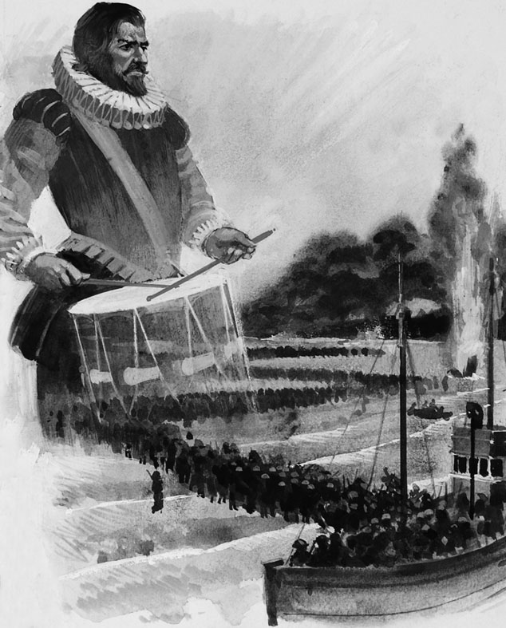

¹ slave [] Sklave

b) Tick () which sentences are right, not in the text, or wrong. Correct the wrong sentences.

 |  | Right | Not in the text | Wrong | Correction
1 It is not clear when Francis Drake’s birthday was.
2 As a child Drake lived far away from the sea.
3 When he was young he worked for a sea captain and they travelled with six ships.
4 People from Africa attacked Drake and the ships.
5 On his second trip Drake was the captain of the smallest ship.
6 A man from his own ship attacked him.
7 They helped poor people in the towns along the coast.
8 The men on the Cacafuego were very rich knights.
9 The sailing trip took five years.
10 After the queen had named him Sir Francis Drake, she gave a big party for him.
11 After all these adventures, many people in his country knew Drake.
workbook page 47 exercise 16 a and b ( only put them in order)
workbook page 49 exercise 20 a and b

